Description of practical assignment

“Gymstone”

# Developers

Edgars Spira, es22027 *(design, business logic development, user*

*interface design, programming of controllers and models)*

# Development environment

It is planned to develop the system in PHP 8.2.3 environment using Laravel 4.5.0. It is planned to use the MySQL database for data storage and the code will be stored on the GitHub.com system.

# Main Functionality

It is planned to develop a gym performance tracker merged with social media elements.

Users can utilize the website’s main functionality, which is tracking sports performance (e.g., lifting weight progression or healthy weight tracking).   
Other users can see others’ training history to see their achievements if the profile is public.

To integrate deeper with the user, experienced creators would be able to create their training plans for any type of workout with detailed descriptions and videos/photos of the exercises, and other users can copy the workout for their use.

# Data registry

The most significant concepts in the system are user, training, exercise, and rating/commenting.

The main elements of the user interface are the user profile, training history, and planning.  
Users can create a new training plan from existing exercises, track progress during the exercise, save it as a new template for future training, or leave it for the user’s history. Single exercises can be added to the profile for later use in the training plan.  
Training plans can be either public or private and can be commented on and rated by other users.

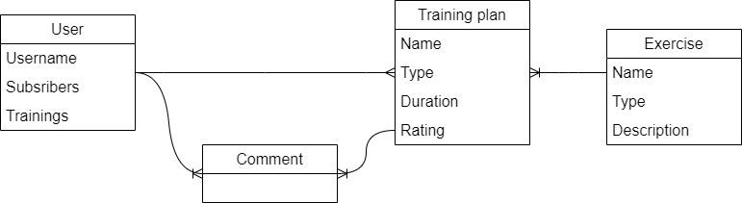

# Model-view-controller (MVC)

The system will be implemented following an MVC paradigm and will be distributed into the following components:

Model:

* User: represents the user of the system, with attributes such as name, email, password, and profile picture.
* Training Plan: represents a training plan created by a user, with attributes such as name, description, exercises, and privacy setting.
* Exercise: represents a specific exercise, with attributes such as name, description, and media files (e.g., photos or videos).
* Rating: represents the rating of a training plan by a user, with attributes such as the rating value.
* Comment: represents the comment on a training plan by a user, with attributes such as the comment text and the user who made it.

View:

* User Profile View: displays the user's information, training history, and saved exercises, with options to create a new training plan or view and copy others' training plans.
* Training Plan View: displays the details of a specific training plan, with options to rate, comment, and copy the plan.
* Exercise View: displays the details of a specific exercise, with options to add the exercise to the user's saved exercises.
* Planning View: displays the interface for creating a new training plan, selecting exercises, and tracking progress.
* Current training View: displays the active training interface, with options to record training progress.

Controller:

* UserController: handles user authentication, registration, and profile management.
* TrainingPlanController: handles creating, updating, deleting, and viewing training plans.
* ExerciseController: handles adding, updating, and viewing exercises.
* RatingController: handles rating training plans.
* CommentController: handles commenting on training plans.
* PlanningController: handles creating and tracking the progress of a new training plan.
* CurrentTrainingController: handles recording and tracking the progress of current training.

# User Roles

The system supports three user roles - a visitor, a registered user, and an administrator. Each of these roles has different operations available in the system.

Administrator:

* Has access to all functionalities of the system, including user management, system configuration, and content management.
* Can create and manage all types of users, including other Super Admins, Admins, Trainers, and Regular Users.
* Can view and edit all user data and system settings.

Regular User:

* Has access to functionalities related to their training plans and exercises, including creating and managing their training plans and exercises.
* Can view and copy other users' public training plans.
* Can rate and comment on other users' public training plans.
* Can view their training history and progress data.

Visitor:

* Limited in functionality. Can only log in or register on the website.

# System Interface

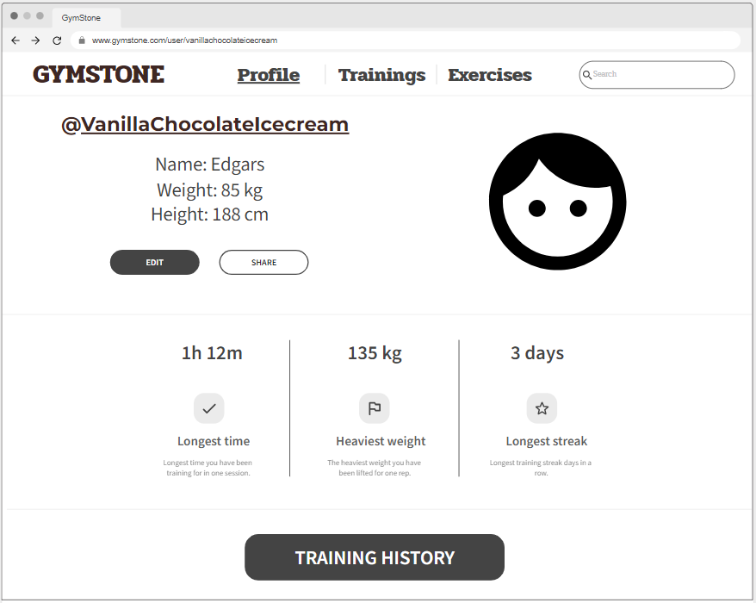The image shows the general design code and profile page of the Registered User, where the user can view their training history, and personal achievements, and view or edit their personal information.